**Computer Organization & Assembly Language**

**Lab 07**

Stack Operations & Procedures

## Instructors:

## NATIONAL UNIVERSITY OF COMPUTER AND EMERGING SCIENCES

**LAB 07**

## Learning Objectives

1. Runtime Stack
2. Push instruction
3. Pop instruction
4. PROC Directive
5. Call & Ret Instructions
6. Nested Procedures

**Stack:**

* LIFO (Last-In, First-Out) data structure.
* push/ pop operations
* You probably have had experiences on implementing it in high-level languages.
* Here, we concentrate on runtime stack, directly supported by hardware in the CPU. It is essential for calling and returning from procedures.

### Runtime Stack:

Managed by the CPU, using two registers

* SS (stack segment)
* ESP (stack pointer): point the last value to be added to, or *pushed* on, the top of stack usually modified by instructions:

- CALL, RET, PUSH and POP

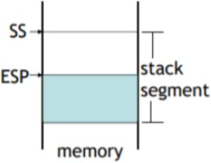

## Push Operation

A 32-bit push operation decrements the stack pointer by 4 and copies a value into the location in the stack pointed to by the stack pointer.

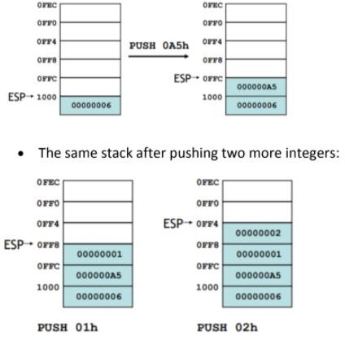

## Pop Operation

A *pop* operation removes a value from the stack. After the value is popped from the stack, the stack pointer is incremented (by the stack element size) to point to the next- highest location in the stack.

It copies value at stack [ESP] into a register or variable.

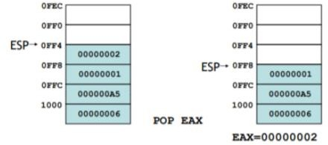

### PUSH and POP instructions:

**PUSH syntax:**

* PUSH r/m16
* PUSH r/m32
* PUSH imm32

### POP syntax:

* POP r/m16
* POP r/m32

### PUSHFD and POPFD Instructions

The MOV instruction cannot be used to copy the flags to a variable.

The PUSHFD instruction pushes the 32-bit EFLAGS register on the stack, and POPFD pops the stack into EFLAGS:

*pushfd popfd*

**Example: Stack and nested loops.**

.code main proc mov ecx,5 L1:

push ecx mov ecx, 10 L2:

inc ebx loop L2 pop ecx loop L1

### Example: displays the product of three integers through a stack

TITLE Reversing a String (Prod.asm) INCLUDE Irvine32.inc

.data

multp DWORD 2

.code

main PROC

mov eax, 1

mov ecx, 3

L1:

PUSH multp

ADD multp, 2

LOOP L1

mov ecx, 3

L2:

POP ebx

MUL ebx ;eax value multiply

LOOP L2

CALL DumpRegs

EXIT

main ENDP

END main

### Example: To find the largest number through a stack

.code

main PROC

PUSH 5

PUSH 7

PUSH 3

PUSH 2

MOV eax, 0 ;eax is the largest

MOV ecx, 4

L1:

POP edx

CMP edx, eax

JL SET

MOV eax, edx

SET:

LOOP L1

CALL DumpRegs

EXIT

main ENDP

END main

## Procedures

* + Procedures or subroutines are very important in assembly language, as the assembly language programs tend to be large in size.
  + Procedures are identified by a name. Following this name, the body of the procedure is described which performs a well-defined job.
  + End of the procedure is indicated by a return statement.

### PROC Directive

We can define a *procedure* as a named block of statements that ends in a return statement. A procedure is declared using the PROC and ENDP directives. It must be assigned a name (a valid identifier). When we create a procedure other than your program’s startup procedure, end it with a RET instruction. RET forces the CPU to return to the location from where the procedure was called:

Let’s say, ***sample*** is the name of procedure.

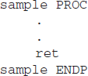

The procedure is called from another function by using the CALL instruction. The CALL instruction should have the name of the called procedure as an argument as shown below

CALL Sample

The called procedure returns the control to the calling procedure by using the RET instruction.

## Call & RET Instructions:

**CALL** instruction is used whenever we need to make a call to some procedure or a subprogram. Whenever a CALL is made, the following process takes place inside the microprocessor:

* + The address of the next instruction that exists in the caller program (after the program CALL instruction) is stored in the stack.
  + The instruction queue is emptied for accommodating the instructions of the procedure. Then, the contents of the instruction pointer (IP) is changed with the address of the first instruction of the procedure.
  + The subsequent instructions of the procedure are stored in the instruction queue for execution.
  + The Syntax for the CALL instruction is mentioned above.

**RET** instruction stands for return. This instruction is used at the end of the procedures or the subprograms. This instruction transfers the execution to the caller program.

Whenever the RET instruction is called, the following process takes place inside the microprocessor:

* The address of the next instruction in the mainline program which was previously stored inside the stack is now again fetched and is placed inside the instruction pointer (IP).
* The instruction queue will now again be filled with the subsequent instructions of the mainline program.

### Example:

INCLUDE Irvine32.inc

.data

var1 DWORD 5

var2 DWORD 6

.code main PROC

call AddTwo call writeint call crlf exit

main ENDP

AddTwo PROC mov eax,var1 mov ebx,var2 add eax,var2 ret

AddTwo ENDP END main

## Example:

INCLUDE Irvine32.inc INTEGER_COUNT = 3

.data

str1 BYTE "Enter a signed integer: ",0 str2 BYTE "The sum of the integers is: ",0 array DWORD INTEGER_COUNT DUP(?)

.code main PROC

call Clrscr

mov esi,OFFSET array mov ecx,INTEGER_COUNT call PromptForIntegers call ArraySum

call DisplaySum exit

main ENDP

PromptForIntegers PROC USES ecx edx esi

mov edx,OFFSET str1 ; "Enter a signed integer"

L1: call WriteString ; display string

call ReadInt ; read integer into EAX

call Crlf ; go to next output line

mov [esi],eax ; store in array

add esi,TYPE DWORD ; next integer loop L1

ret

PromptForIntegers ENDP

ArraySum PROC USES esi ecx

mov eax,0 ; set the sum to zero L1: add eax,[esi] ; add each integer to sum add esi,TYPE DWORD ; point to next integer loop L1 ; repeat for array size

ret ; sum is in EAX

ArraySum ENDP

DisplaySum PROC USES edx mov edx,OFFSET str2

call WriteString

call WriteInt ; display EAX call Crlf

ret

DisplaySum ENDP END main

Page | 6

Page | 7

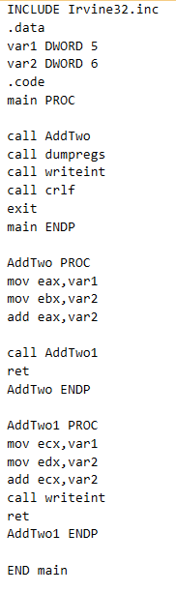

## Nested Procedure Calls

A nested procedure call occurs when a called procedure calls another procedure before the first procedure returns.

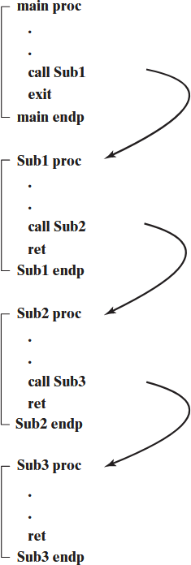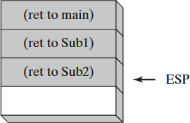

**Example:**

**Exercise: Run on IDE**

**Task#1:**

Take an array of 10 numbers move word-type of data into another empty array using stack push and pop technique.

**Task#2**

Write a program which displays the addition of three integers through a stack.

**Task#3**

Write a program having nested procedures are used to calculate the total sum of 2 arrays (each array having 5-elements). The sum of 1-array in 1st procedure and in 2nd procedure have sum of 2-array. And the 3rd procedure added the results of both.

**Task#4**

Print the following pattern using a function call in which number of columns is pass through a variable.

**\***

**\*\***

**\*\*\***

**\*\*\*\***

**\*\*\*\*\***

**Task#5**

Print the following pattern using a function call in which number of columns is pass through a variable.

**A BC DEF GHIJ KLMN**

**Task#6**

Write a function that asks the user for a number n and prints the sum of the numbers 1 to n

Page | 8